Exercice Culture Info

Exercice 1:

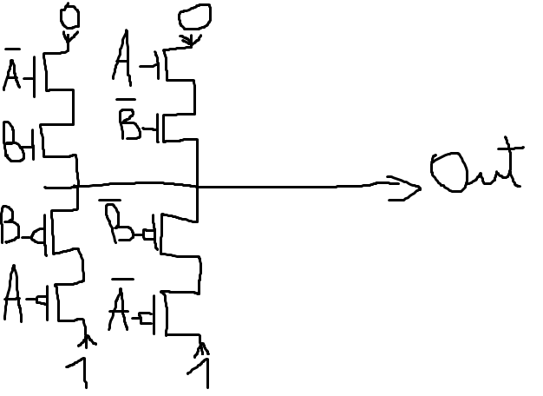
Exercice 2:
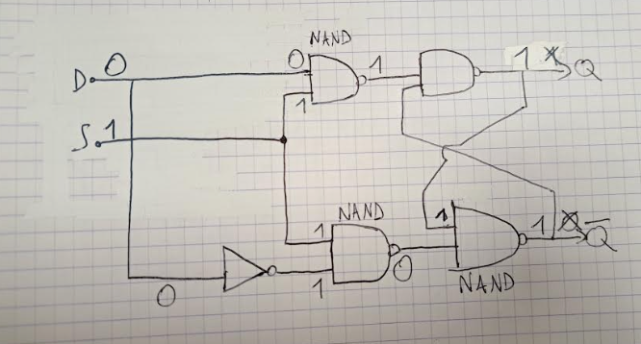
Exercice 3:
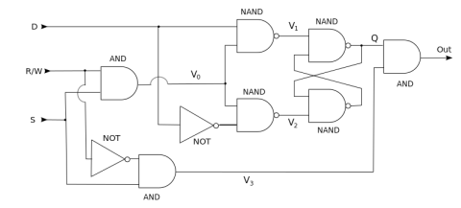

D | S | R/W | V0 | V1 | V2 | V3 | Q | Out
0  1  0  1  0  1  0  1 | 0  0  1  1  1  1  0  0 | 1  1  1  1  0  0  0  0 | 0  0  1  1  0  0  0  0 | 1  1  1  0  1  1  1  1 | 1  1  0  1  1  1  1  1 | 0  0  0  0  1  1  0  0 | 1  1  0  1  1  1  1  1 | 0  0  0  0  1  1  0  0

Exercice 4:

1) On a deux cas:
-Si un des entrées = 0 alors out= 0;
-Si toutes les entrées = 1 alors out= 1;

2)
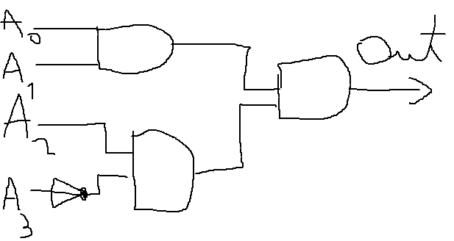

Exercice 5:
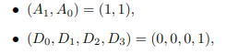

:

(S0,S1,S2,S3)= (0,0,0,0)

:

(S0,S1,S2,S3)= (0,0,0,1)

